 

A Minor Project Report On

## SMART CAR PARKING SYSTEM

Submitted in partial fulfilment of requirements for the award of theDegree of

##### BACHELOR OF ENGINEERING

in

##### COMPUTER SCIENCE AND ENGINEERING

Under the guidance of

##### Mrs. S. SANTHIYA Assistant Professor/CSE

Submitted By

##### MARUTHANAYAGAM . S (927621BCS067)

**NAVEENKUMAR .G VIGNESH . S LOGESH . S**

##### (927621BCS074) (927621BCS122) (927621BCS305)

**DEPARTMENT OF COMPUTER SCIENCE AND ENGINEERING**

**M.KUMARASAMY COLLEGE OF ENGINEERING**

(Autonomous) **KARUR –**May,2023

 

**M. KUMARASAMYCOLLEGE OF ENGINEERING**

**(Autonomous Institution affiliated to Anna University, Chennai)**

### KARUR – 639113

**BONAFIDE CERTIFICATE**

Certified that this minor project report **“SMART CAR PARKING**

##### SYSTEM” is (927621BCS067), (927621BCS122),

the bonafide work of **“MARUTHANAYAGAM.S NAVEENKUMAR.G (927621BCS074), VIGNESH.S**

**LOGESH .C.N (927621BCS305)”** who carried out project work during the academic year 2020-2021 under my supervision.

|  |  |
| --- | --- |
| Signature | Signature |
| **Mrs .S.SANTHIYA M.E.,** | **Dr. M. MURUGASAN M.E., Ph.D.,** |
| **SUPERVISOR,** | **HEAD OF THE DEPARTMENT,** |
| Department of Computer Science | Department of Computer Science |
| and Engineering, | and Engineering, |
| M. Kumarasamy College of Engineering, | M. KumarasamyCollege of Engineering |
| Thalavapalayam, Karur -639113 | Thalavapalayam, Karur -639113. |

 

**DEPARTMENT OF COMPUTER SCIENCE AND ENGINEERING**

**VISION OF THE INSTITUTION**

To emerge as a leader among the top institutions in the field of technical education

**MISSION OF THE INSTITUTION**

Produce smart technocrats with empirical knowledge who can surmount the global challenges

 Create a diverse, fully-engaged, learner-centric campus environment to provide quality education to the students

 Maintain mutually beneficial partnerships with our alumni, industry, and Professional associations

**VISION OF THE DEPARTMENT**

To achieve education and research excellence in Computer Science and Engineering

**MISSION OF THE DEPARTMENT**

To excel in academic through effective teaching learning techniques

 To promote research in the area of computer science and engineering with the focus on innovation

To transform students into technically competent professionals with societal and ethical responsibilities

**PROGRAM EDUCATIONAL OBJECTIVES (PEOs)**

**PEO 1:**Graduates will have successful career in software industries and R&D divisions through continuous learning.

**PEO 2:** Graduates will provide effective solutions for real world problems in the key domain of computer science and engineering and engage in lifelong learning.

**PEO 3:** Graduates will excel in their profession by being ethically and socially responsible.

 

**PROGRAM OUTCOMES (POs)**

Engineering students will be able to:

1. **Engineering knowledge:** Apply the knowledge of mathematics, science, engineering

fundamentals, and an engineering specialization to the solution of complex engineering problems.

1. **Problem analysis:** Identify, formulate, review research literature, and analyze complex engineering problems reaching substantiated conclusions using first principles of mathematics, natural sciences, and engineering sciences.
2. **Design/development of solutions:** Design solutions for complex engineering problems and design system components or processes that meet the specified needs with appropriate consideration for the public health and safety, and the cultural, societal, and environmental considerations.
3. **Conduct investigations of complex problems:** Use research-based knowledge and research methods including design of experiments, analysis and interpretation of data, and synthesis of the information to provide valid conclusions.
4. **Modern tool usage:** Create, select, and apply appropriate techniques, resources, and modern engineering and IT tools including prediction and modeling to complex engineering activities with an understanding of the limitations.
5. **The engineer and society:** Apply reasoning informed by the contextual knowledge to assess societal, health, safety, legal and cultural issues and the consequent responsibilities relevant to the professional engineering practice.
6. **Environment and sustainability:** Understand the impact of the professional engineering solutions in societal and environmental contexts, and demonstrate the knowledge of, and need for sustainable development.
7. **Ethics:** Apply ethical principles and commit to professional ethics and responsibilities and

norms of the engineering practice.

1. **Individual and team work:** Function effectively as an individual, and as a member or leader in diverse teams, and in multidisciplinary settings.
2. **Communication:** Communicate effectively on complex engineering activities with the engineering community and with society at large, such as, being able to comprehend and write effective reports and design documentation, make effective presentations, and give and receive clear instructions.

 

1. **Project management and finance:** Demonstrate knowledge and understanding of the engineering and management principles and apply these to one’s own work, as a member and leader in a team, to manage projects and in multidisciplinary environments.
2. **Life-long learning:** Recognize the need for, and have the preparation and ability to engage in independent and life-long learning in the broadest context of technological change.

**PROGRAM SPECIFIC OUTCOMES (PSOs)**

**PSO1: Professional Skills:** Ability to apply the knowledge of computing techniques to

design and develop computerized solutions for the problems.

 **PSO2: Successful career:** Ability to utilize the computing skills and ethical values in creating a successful career.

 

### ABSTRACTWITH POAND PSO MAPPING

|  |  |  |
| --- | --- | --- |
| **ABSTRACT** | **POs**  **MAPPED** | **PSOs**  **MAPPED** |
| The main aim of this project is to create a completely automated carparking system with minimal human interference. The fully automated smart car parking system is rudimental and does not require heavy lines of code nor expensive equipment. It is a simple circuit built for the exact need of purpose. This automated system is used to find the vacancy in parking spaces available and navigate the driver to reach the desired space using visuals and in an effective manner, thus reducing search time. This system is required for malls, multistorey parking structures, IT hubs and parking facilities. Smart Parking System that uses cluster based algorithm to handle the dynamic parking allocation problem .In our project we propose a smart and car parking model that will help the user in booking their parking spaces beforehand | **PO1(3)**  **PO 2(3)**  **PO 3(2)**  **PO 4(2)**  **PO 5(2)**  **PO6(1)**  **PO 7(3)**  **PO 8(2)**  **PO 9(3)**  **PO 10(3)**  **PO 11(2)**  **PO 12(2)** | **PSO 1(3)**  **PSO 2(2)** |

#### Note: 1- Low, 2-Medium, 3- High

**SUPERVISOR HEAD OF THE DEPARTMENT**

### ABSTRACT

The main aim of this project is to create a completely automated carparking system with minimal human interference. The fully automated smart car parking system is rudimental and does not require heavy lines of code nor expensive

equipment. It is a simple circuit built for the exact need of purpose. This automated system is used to find the vacancy in parking spaces available and navigate the driver to reach the desired space using visuals and in an effective manner, thus reducing search time. This system is required for malls, multistorey parking structures, IT hubs and parking facilities. Smart Parking System that uses cluster based algorithm to handle the dynamic parking allocation problem .In our project we propose a smart and car parking model that will help the user in booking their parking spaces beforeha

# TABLE OF CONTENTS

##### CHAPTER TITLE PAGE NO

**Abstract**

##### List of Figures

**Acronyms/ LisofAbbrevations**

##### INTRODUCTION

viii

ix

1.1 Relevance of the project 1

1 1.2 Problem Statement 2

* 1. Objective 2
  2. Scope of the project

3

* 1. Methodology 3

**LITERATURE SURVEY**

2

2.1 Technical and research papers 5

##### SYSTEM REQUIREMENTS SPECIFICATION

3 3.1 Functional Requirements 9

* 1. Non-Functional Requirements

9

* 1. Hardware Specifications

10

3 3.4 Software Specifications 10

**SYSTEM ANALYSIS AND DESIGN**

4.1 Aruidno UNO 11

4 4.2 20*4 LCD Display 12

* 1. IR Sensors 12
  2. Servor Motor 13
  3. Jumper Wires 14
  4. Magnetic Coil

14

* 1. I 2c Module 14

5 IMPLEMENTATION

5.5 Planing 18

* 1. Sensor Installation 18
  2. Microcontroller Board Installation 18
  3. Installation Cloud-based Platform Setup 18
  4. Display Screen Installation 18
  5. Parking Gate Or Barrier Installation: 18

6 20

|  |
| --- |
| . |
| **TESTING** |

1. WIRELESS CHARGING IN PARKINGSPOT 21
2. PROGRAM 25
3. RESULT AND DISCUSSION 28
4. CONCLUSION 30

xi

**LIST OF FIGURES**

**Page no**

|  |  |
| --- | --- |
| **Figures** | **page** |
| **1.1**  **2.1** | **Block Diagram of Smart Parking System**  **Entity relationship diagram of smart parkin** |
| **4.1** | **Aruidno uno** |

1

**g** 6

11

**4.2**

**4.3**

**4.4**

**4.5**

**4.6**

**4.7**

**4.8**

**5.1**

**6.1**

**8.1**

**8.2**

**8.3**

**8.4**

**8.5**

**9.1**

**9.2**

**9.3**

##### 20*4 Dispalay 12

##### IR Sensor 13

##### Servor Motor 13

##### Jumper Wires 14

##### Magnetic coil 15

##### I 2c Module 16

##### Circuit Diagram 17

##### Implementation of smart car parking system 19

##### Wireless charging in EV Vechile 20

##### Shows both parking slot empty on the model 25

##### Case of one parking slot filled on the model 26

##### Updating the count of vacant and filledspotand 26

##### displaying it

##### User unparking his vehicle from the slot 27

##### wireless charging in EV vechile 27

##### Showing the intial setup of the project 28

##### When parking spot is filled 28

##### When parking spot is not filled 29

xi

**LIST OFACRONYMS / ABBREVIATIONS**

IDE Integrated Development Environment

IR Infrared Sensor

## EV Electric Vehicle

LCD Liquid-crystal display

xi

**CHAPTER 1**

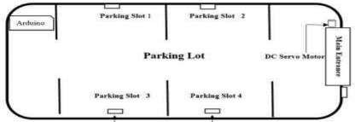

# INTRODUCTION

The project entitled smart parking system is to manage all the parking facilities to an user. The recent growth in economy and due to the availability of low price cars in the market, an every average middle-class individual can afford a car, which is good thing, however the consequences of heavy traffic jams, pollution, less availability of roads and spot to drive the motor car. One of the important concerns, which is to be taken in accounting, is the problem of parking those vehicles .Though, if there is space for parking the vehicle but so much time is squandered in finding that exact parking slot resulting in more fuel intake and not also environment friendly. It will be a great deal if in some way we find out that the parking itself can provide the precise vacant position of a parking slot then it'll be helpful not limited to the drivers also for the environment . Initially when the user is about to enter the location the LCD displays the number of empty and filled spots and when the user is with its vehicle near to the parking detect sensor ,he/she would be thrown with a notification on their mobile app of the parking slot number ,where they should park there vehicle.

##### Relevance of the project

The main important benefit of a smart parking system is its advanced technology. It follows the latest technologies and concepts to assure profitable outcomes . The design and implementation of smart parking is very easy to supervise and manage. This system can be easily handled by the staff members because of its well organized structure.

**Fig 1.1** Shows the block diagram of smart parking system

##### Problem Statement

In recent research in metropolitan cities the parking management problem can be viewed from various angles such as high vehicle density on roads. This results in annoying issues for the drivers to park their vehicles as it is very difficult to find a parking slot.

The drivers usually waste time and effort in finding parking space and end up parking their vehicles finding a space on the street which further leads to space congestion. In worst case, people fail to find any parking space especially during peak hours and festive season.

##### Objective

Smart Parking involves the use of low cost sensors, real-time data and applications that allow users to monitor available and unavailable parking spots. The goal is to automate and decrease time spent manually searching for the optimal parking floor, spot and even lot. Some solutions will encompass a complete suite of services such as online payments, parking time notifications and even car searching functionalities for very large lots. A parking solution can greatly benefit both the user and the lot owner.

**Optimized parking** – Users find the best spot available, saving time, resources and

effort. The parking lot fills up efficiently and space can be utilized properly by commercial and corporate entities.

**Reduced traffic** – Traffic flow increases as fewer cars are required to drive around in search of an open parking space.

**Reduced pollution** – Searching for parking burns around one million barrels of oil a day. An optimal parking solution will significantly decrease driving time, thus lowering the amount of daily vehicle emissions and ultimately reducing the global environmental footprint.

**Increased Safety** – Parking lot employees and security guards contain real-time lot data that can help prevent parking violations and suspicious activity. License plate recognition cameras can gather pertinent footage. Also, decreased spot-searching traffic on the streets can reduce accidents caused by the distraction of searching for parking.

**Decreased Management Costs** – More automation and less manual activity saves on low cost and resource exhaustion.

**Enhanced User Experience** – A smart parking solution will integrate the entire user experience into a unified action. Driver’s payment, spot identification, location search and time notifications all seamlessly become part of the destination arrival process.

* 1. **Scope of the project**

At present some countries have portals which users can gain information about parking areas via the internet. This system can give users the information about parking space, but it won’t be able to give which parking slot is vacant and occupied. Hence, such a system cannot smartly handle the issue. Car lifts along with an automated robotic system, which automatically takes the car to a particular parking spot as soon as the car enters on a platform. This system cannot be installed by medium scale shopping malls, movie theatres as it can cost them a huge amount. At many public places, the system only shows the availability but it cannot show the exact slot and path to the slot available. Hence, there is the need to smartly find the path to the vacant spot.

##### Methodology

Smart car parking using Arduino Uno involves setting up sensors on an Arduino Uno board, programming the board to control the sensors, installing the sensors in the parking lot, calibrating them, testing the system, displaying parking information, and maintaining the system. The hardware setup involves connecting sensors, display screens, LED lights, and buzzers to the Arduino Uno board. The programming is done using the Arduino IDE to write code for detecting when a car is present in a parking spot, determining whether the spot is available or occupied, and sending this information to the display screen or other output devices. The sensors are installed in each parking spot and calibrated to ensure accurate readings. The system is tested for different scenarios, such as when a car is parked too close to the sensor or at an angle. The parking information is displayed on the screen or other output device. Regular maintenance is required to ensure that the sensors are working correctly and the system is up-to-date.

The sensors used in smart car parking systems can include ultrasonic or infrared sensors. Ultrasonic sensors use sound waves to detect the presence of a car, while infrared sensors use light waves. Both types of sensors can be effective, but ultrasonic sensors may be more reliable in detecting vehicles in adverse weather conditions. Additionally, smart car parking systems can be designed to include features such as automatic payment systems or the ability to reserve parking spaces ahead of time. Finally, smart car parking systems can improve traffic flow in parking lots by providing real-time information about available spaces and directing drivers to open spots.

### CHAPTER 2

##### LITERATURE SURVEY

**[1] Developing a Smart Parking Management System Using the Internet of Things**

Searching for parking wastes significant amounts of time and effort and leads to substantial financial costs. This is particularly the case for people who are always pressured to be on time. Smart cities employ all kinds of modern technologies to manage and enhance resources effectively. Urban parking facilities are one of the essential assets that must be managed. We developed a smart parking management system (SPMS) as a modern solution to manage parking and save users time, effort and cost. In the context of today’s modern life, it has become necessary to improve search methods for available parking and minimize the congestion that occurs at the parking entrance. Searching or booking available parking online earlier is a better substitute than searching at a parking lot where there is a possibility of not being able to find parking. Our smart parking management system was developed to:

* Apply technical solutions to improve the smart cities concept
* Manage parking and solve problems efficiently using technology

The proposed system uses a variety of technologies that help manage parking. It provides essential services for users, including searching for parking, reservations and payment. It is extended to cover more advanced services such as receiving notifications, statistics and monitoring the parking state.

The system is connected to sensors to detect occupancy and an automatic number plate recognition (ANPR) camera to control access. The remainder of the paper is organized as follows.

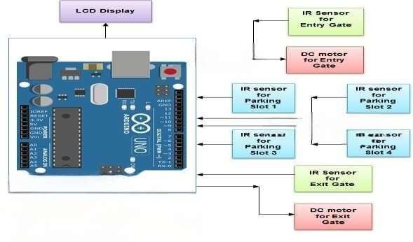

##### Fig 2.1 Entity Relationship Diagram of Smart Parking System

1. **An IoT-based E-Parking System for Smart Cities :**

The huge proliferation in the number of vehicles on the road along with mismanagement of the available parking space has created parking related problems as well as increased the traffic congestion in urban areas. Thus, it is required to develop an automated

smart parking management system that would not only help a driver to locate a suitable parking space for his/her vehicle, but also it would reduce fuel consumption as well as air pollution. It has been found that a drivers search for a suitable parking facility takes almost 15 minutes which increases the fuel consumption by the vehicle, traffic congestion and air pollution. A significant amount of research works exist in the area of design and development of smart parking system. Various features of smart parking system are listed below.

* Inquiry on availability of parking space and reservation of parking lot
* Real-time parking navigation and route guidance
* Vehicle occupancy detection and management of parking lots .

Most of the smart parking systems (SPS) proposed in literature over the past few years provides solution to the design of parking availability information system, parking reservation system, occupancy detection and management of parking lot, real-time navigation within the parking facility**.**

##### Smart Parking based System for smarter cities

The existing system comprises of both traditional and application based approach for parking. If we talk about the traditional approach it utilizes manual method of parking i.e user has to find the spot for parking by traveling to far distances and paying extra money. An application based approach consist of the applications which provides the parking slots for the particular locality for example .The application named ‘Parking Panda ’ provides the parking slots to the areas like stadium, sports leagues etc.

1. **SYSTEM TO REDUCE TRAFFIC CONGESTION**

A smart parking system can be an effective solution to reduce traffic congestion in urban areas. Traffic congestion can be caused by several factors, such as inadequate parking spaces, drivers circling around the block searching for a parking spot, or vehicles parked illegally in no-parking zones. By implementing a smart parking system that uses technology like Arduino Uno to monitor parking availability and direct drivers to available spots, traffic congestion can be significantly reduced. The system can provide real-time information about parking availability through display screens or mobile apps, allowing drivers to make informed decisions and save time. In addition, smart parking systems can also reduce the number of cars on the road by allowing drivers to reserve a parking spot ahead of time, which minimizes the need to drive around searching for a spot. Ultimately, a smart parking system can help alleviat.

.

##### An IoT-Based Intelligent System for Real-Time Parking Monitorin

An IoT-based intelligent system for real-time parking monitoring can be an effective solution to manage parking spaces efficiently and provide a better parking experience for drivers. The system uses Internet of Things (IoT) technology to monitor parking availability in real-time and guide drivers to open spots. The system consists of sensors installed in each parking spot, a gateway device that

collects data from the sensors, and a cloud-based platform that processes and analyzes the data. The system can provide real-time information about parking availability through a mobile app or other output device, allowing drivers to make informed decisions and save time. The system can also predict parking availability based on historical data and make recommendations to drivers based on their preferences, such as proximity to a particular location or price. Furthermore, the system can also be used to monitor parking violations and issue tickets automatically, reducing the need for manual enforcement. Overall, an IoT-based intelligent system for real-time parking monitoring can provide numerous benefits, including efficient use of parking spaces, reduced congestion and emissions, and improved parking experiences for

# CHAPTER –3

**SYSTEM REQUIREMENTS SPECIFICATION**

##### Functional Requirements

**Vehicle detection**: The system should be able to detect the presence or absence of

vehicles in parking spaces, using sensors such as ultrasonic or infrared sensors.

**Real-time monitoring**: The system should be able to provide real-time monitoring of parking availability, occupancy, and turnover rates to users, such as drivers and parking operators.

**Remote control and management**: The system should be able to allow remote control and management of the parking facilities, including monitoring and maintenance of the sensors, actuators, and other components.

**User-friendly interface**: The system should be able to provide a user-friendly interface for drivers and parking operators, allowing easy access to parking availability, occupancy, and payment information.

**Environmental sustainability**: The system should be able to promote environmental sustainability, by using energy-efficient components, such as LED lights, and supporting alternative modes of transportation, such as electric vehicle charging stations.

##### Non-Functional Requirement

Non-functional requirements are the requirements which are not directly concerned with the specific function delivered by the system. They specify the criteria that can beused to judge the operation of a system rather than specific behaviours.

Given below are the non-functional requirements:

* Product requirements
* Organizational requirements
* Basic operational requirements

##### Hardware Specifications

* + - ARUIDNO UNO
    - I 2C MODULE
    - JUMPER WIRES
    - INFRARED SENSOR
    - 20*4 LED DISPLAY
    - MAGNETICCOIL
  1. **Software Specifications**
* ARUIDNO IDE
* WINDOWS 11

**CHAPTER 4**

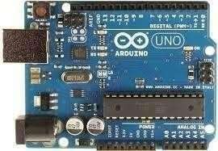

**SYSTEM ANALYSIS AND DESIGN**

### 4.1 Aruidno uno

Arduino Uno can be used in a smart car parking system to monitor parking availability, guide drivers to open spots, and provide real-time information about parking occupancy. The system can be designed using sensors, such as ultrasonic or infrared sensors, installed in each parking spot to detect the presence of a vehicle. The sensors can be connected to an Arduino Uno board that collects and processes the data, and sends it to a cloud-based platform for further analysis. The system can provide real-time information about parking availability through a mobile app or display screens, allowing drivers to make informed decisions and save time. The system can also be designed to include features such as automatic payment systems or the ability to reserve parking spaces ahead of time. Furthermore, Arduino Uno can be used to control parking gates or barriers, allowing smart car parking system can provide a more efficient and convenient parking experience for drivers while maximizing the use of parking spaces and reducing congestion.

**Fig. 4.1**. **Aruidno UNO**

### 3.1 20*4 LCD Display

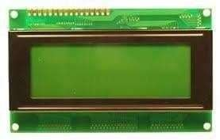A 20*4 LCD display can be used in a smart car parking system to provide real-time information about parking occupancy, available spots, and directions to open spots. The LCD display can be connected to an Arduino Uno board or other microcontroller board that collects data from sensors installed in each parking spot. The LCD display can be programmed to show the number of available spots in different sections of the parking lot, the status of each parking spot (occupied or available), and directions to open spots. The display can also be designed to show parking rates, payment instructions, and other relevant information. Additionally, the LCD display can be used in combination with other output devices, such as mobile apps or display screens, to provide a comprehensive parking guidance system for drivers. Overall, using a 204 LCD display in a smart car parking system can improve the parking experience for drivers and help reduce congestion and emissions in urban areas.

**Fig :4.2 16*2 LCD DISPLAY**

### IR sensor

An infrared (IR) sensor is an electronic device that measures and detects infrared radiation in its surrounding environment. Infrared radiation was accidentally discovered by an astronomer named William Herchel in 1800. While measuring the temperature of each color of light (separated by a prism), he noticed that the temperature just beyond the red light was highest. IR is invisible to the human eye, as its wavelength is longer than that of visible light (though it is still on the same electromagnetic spectrum). Anything that emits heat (everything that has a temperature [above around](https://www.livescience.com/50260-infrared-radiation.html) [five degrees Kelvin](https://www.livescience.com/50260-infrared-radiation.html)) gives off infrared radiation. We are using three IR detect sensor in our project , one IR detect sensor is used to sense the vehicle near the parking sensor and other two IR detect sensor is used to send data to the node mcu which is the brain of our system whether a vehicle is parked in that slot or is unparked .

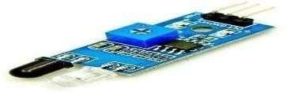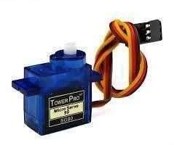

**Fig: 4.3 IR sensor**

##### SERVOR MOTOR

A servo motor is a type of motor that is commonly used in a smart car parking system to control the movement of various components, such as gates, barriers, and ramps. Servo motors are often preferred because they are precise, reliable, and can be programmed to move in specific ways, allowing for greater control and automation. In a smart car parking system, servo motors can be used to control the opening and closing of gates at the entrance and exit, as well as to move parking barriers and ramps to direct vehicles to their designated parking spaces. Servo motors can also be used in other components of the parking system, such as in the payment kiosks to dispense tickets or receipts. Overall, the use of servo motors in a smart car parking system can help to increase efficiency, improve accuracy, and enhance the overall user experience.

##### Fig : 4.4 Servor motor

* 1. **JUMPER WIRES**

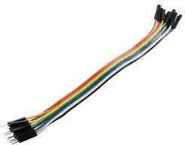Jumper wires can play an important role in a smart car parking system by connecting various electronic components and modules together. In a smart car parking system, jumper wires can be used to connect sensors that detect the presence of vehicles in parking spaces, microcontrollers that process the data from these sensors, and actuators such as servo motors that control the movement of gates and barriers. Additionally, jumper wires can be used to connect components of the payment system, such as coin or bill validators and receipt printers. By using jumper wires, the components in the smart car parking system can be easily and quickly connected or disconnected, making it easier to modify or repair the system if needed. It is important to use high-quality jumper wires that are rated for the voltage and current requirements of the system to ensure proper functionality and safety. The use of jumper wires in a smart car parking system allows for flexibility and modularity in the design and implementation of the system, helping to create a more efficient and reliable parking solution.

##### Fig :4.5 Jumper Wires

* 1. **MAGNETIC COIL**

In an electric vehicle (EV), magnetic coils are used in the motor to convert electrical energy into mechanical energy to drive the wheels. The motor consists of a stator (stationary part) and a rotor (rotating part), both of which have magnetic fields.The stator has a set of coils that are arranged around the rotor. When an electric current flows through these coils, they create a magnetic field. The rotor has a set of permanent magnets that also create a magnetic

field. The interaction between the magnetic fields of the stator and the rotor causes the rotor to rotate, thereby driving the wheels of the EV. The motor is designed so that the magnetic fields of the stator and the rotor are always out of phase with each other. This means that as the rotor turns, the magnetic fields of the stator are constantly changing, which generates a torque that drives the rotor

##### Fig : 4.6 Magnetic Coil

* 1. **I 2C MODULE**

An I2C (Inter-Integrated Circuit) module can be used in a smart car parking system to enable communication between different electronic components of the system, such as sensors, microcontrollers, and actuators. I2C is a serial communication protocol that allows multiple devices to communicate with each other using a common bus, consisting of two lines: SDA (Serial Data) and SCL (Serial Clock).

In a smart car parking system, an I2C module can be used to connect and communicate with different sensors that detect the presence or absence of vehicles in parking spaces, as well as microcontrollers that process this data and send commands to actuators such as servo motors that control gates and barriers. By using an I2C module, the system can efficiently transmit data between the different components, reducing the amount of wiring required and simplifying the overall design.

Additionally, an I2C module can be used in a smart car parking system to interface with other modules, such as displays or payment systems. For example, an I2C-enabled display can be used to provide real-time information to drivers about available parking spaces or payment options, while an I2C-enabled payment module can be used to process payment transactions securely and efficiently.

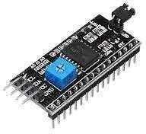

Overall, the use of an I2C module in a smart car parking system can improve the efficiency, reliability, and overall performance of the system by enabling efficient communication between different components and modules.

**Fig : 4.7 I 2c Module**

### SystemArchitecture

**Sensors**: Sensors are installed in each parking spot to detect the presence of a vehicle. These sensors can be of various types such as ultrasonic or infrared sensors.

**Microcontroller board**: A microcontroller board such as Arduino Uno or Raspberry Pi is used to collect data from the sensors and process it. The microcontroller board can be connected to the internet through a wired or wireless connection.

**Cloud-based platform :** The cloud-based platform receives data from the microcontroller board and processes it to provide real-time information about parking occupancy, available spots, and directions to open spots. This platform can be hosted on the cloud or on a local server.

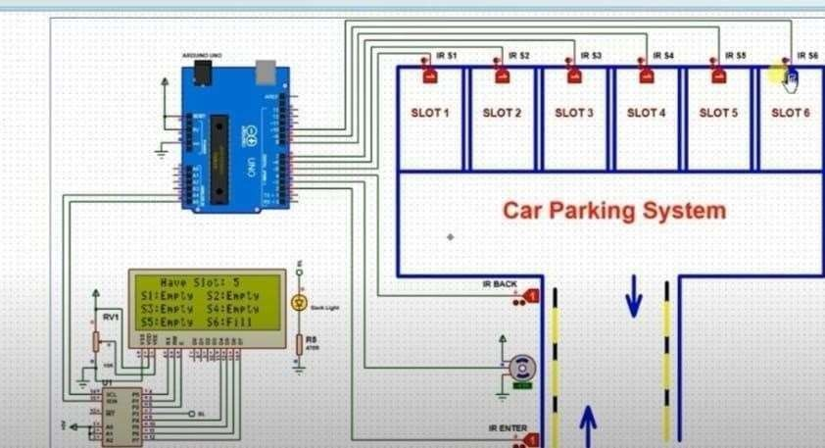

**Display screen :** A display screen is used to provide real-time information about parking availability and guide drivers to open spots. This display screen can be located at the entrance of the parking lot or in different sections of the parking lot.

**Parking gate or barrier :** The parking gate or barrier allows only authorized vehicles to enter and exit the parking lot. The gate or barrier can be controlled by the microcontroller board or by a separate controller.

##### Fig 4.8 Circuit Diagram

**CHAPTER 5**

# IMPLEMENTATION

##### 5. The implementation of a smart car parking system involves the following steps:

* 1. **PLANING:**

The first step is to plan the implementation of the system. This includes identifying the parking lot or area where the system will be installed, determining the number of parking spots, and selecting the appropriate sensors and microcontroller board.

* 1. **SENSOR INSTALLATION:**

The next step is to install sensors in each parking spot. The sensors can be installed above the parking spot or in the ground. The type of sensor used can vary depending on the requirements of the parking lot.

* 1. **MICROBOARD INSTALLATION:**

Once the sensors are installed, the microcontroller board such as Arduino Uno or Raspberry Pi is installed. The microcontroller board is connected to the sensors and the cloud-based platform.

* 1. **CLOUD-BASED PLATFORM SETUP:**

The cloud-based platform is set up to receive data from the microcontroller board

and process it. The platform can be hosted on the cloud or on a local server**.**

* 1. **DISPLAY SCREEN INSTALLATION:**

. The display screen is installed at the entrance of the parking lot or in different sections of the parking lot. The display screen shows real-time information about parking availability and guides drivers to open spots

* 1. **PARKING GATE OR BARRIER INSTALLATION**:

The parking gate or barrier is installed to control the entry and exit of vehicles. The gate or barrier can be controlled by the microcontroller board or by a separate controller.

* 1. **TESTINGAND MAINTENANCE:**

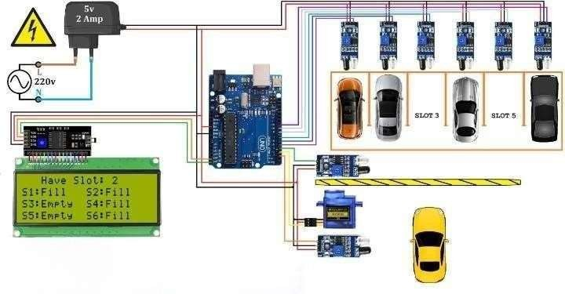

Once the system is installed, it is tested to ensure that it is functioning properly . Regular maintenance is required to ensure that the system continues to function proper.

**Fig : 5.1 Implementation of smart car parking system**

# CHAPTER - 6

**WIRELESS CHARGING IN PARKING SLOT**

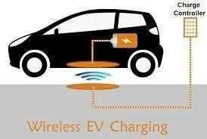

##### Fig : 6.1 Wireless charging in EV Vechile

Wireless charging in EV (electric vehicle) vehicles is a technology that allows the EV to charge its battery without needing to be plugged in using cables. This technology uses an inductive charging method, where an electromagnetic field is used to transfer energy from a charging pad or mat to a receiver coil in the EV. The charging pad is usually installed on the ground or a surface, and the EV is parked directly above it.

Wireless charging in EVs has several advantages over traditional wired charging methods. Firstly, it is more convenient as the EV driver does not have to physically plug the car into a charging station. Instead, they can park the car over a wireless charging pad and the charging process begins automatically. This can be particularly useful in situations where the driver may not have easy access to a charging cable or when charging stations are not readily available.

Wireless charging is also more efficient than traditional charging methods, with less energy wasted during the charging process. Additionally, it is also more durable, as there are no cables or connectors that can become worn or damaged over time.

# CHAPTER 7

**PROGRAM** :

include <Servo.h> //includes the servo library #include <Wire.h>

#include <LiquidCrystal_I2C.h> LiquidCrystal_I2C lcd(0x3F,20,4,20);

Servo myservo; #define ir_enter 2

#define ir_back 4

#define ir_car1 5

#define ir_car2 6

#define ir_car3 7

#define ir_car4 8

#define ir_car5 9

#define ir_car6 10

int S1=0, S2=0, S3=0, S4=0, S5=0, S6=0;

int flag1=0, flag2=0; int slot = 6;

void setup(){ Serial.begin(9600);

pinMode(ir_car1, INPUT); pinMode(ir_car2, INPUT); pinMode(ir_car3, INPUT); pinMode(ir_car4, INPUT); pinMode(ir_car5, INPUT); pinMode(ir_car6, INPUT);

pinMode(ir_enter, INPUT); pinMode(ir_back, INPUT);

myservo.attach(3);

myservo.write(180);

lcd.begin(); lcd.setCursor (0,1);

lcd.print(" Car parking "); lcd.setCursor (0,2); lcd.print(" System ");

delay (1500); lcd.clear();

Read_Sensor();

int total = S1+S2+S3+S4+S5+S6;

slot = slot-total;

}

void loop(){ Read_Sensor(1);

lcd.setCursor (0,0); lcd.print(" Have Slot: "); lcd.print(slot); lcd.print(" ");

lcd.setCursor (0,1); if(S1==1)

{

lcd.print("S1:Fill ");

}

else

{

lcd.print("S1:Empty");

}

lcd.setCursor (10,1); if(S2==1){

lcd.print("S2:Fill ");

}

else

{

lcd.print("S2:Empty");

}

lcd.setCursor (0,2); if(S3==1){

lcd.print("S3:Fill ");

}

else{ lcd.print("S3:Empty");

}

lcd.setCursor (10,2); if(S4==1){

lcd.print("S4:Fill ");

}

else

{

lcd.print("S4:Empty");

}

lcd.setCursor (0,3);

if(S5==1)

{

lcd.print("S5:Fill ");

}

else

{

lcd.print("S5:Empty");

}

lcd.setCursor (10,3); if(S6==1)

{

lcd.print("S6:Fill ");

}

else{ lcd.print("S6:Empty");

}

if(digitalRead (ir_enter) == 0 && flag1==0){ if(slot>0){flag1=1; if(flag2==0){myservo.write(180); slot = slot-1;}

}else{

lcd.setCursor (0,0);

lcd.print(" Sorry Parking Full "); delay(1500);

}

}

if(digitalRead (ir_back) == 0 && flag2==0){flag2=1; if(flag1==0){myservo.write(180); slot = slot+1;}

}

if(flag1==1 && flag2==1){ delay (1500); myservo.write(90); flag1=0, flag2=0;

}

delay(2);

}

void Read_Sensor();

S1=0, S2=0, S3=0, S4=0, S5=0, S6=0;

if(digitalRead(ir_car1) == 0){S1=1;} if(digitalRead(ir_car2) == 0){S2=1;} if(digitalRead(ir_car3) == 0){S3=1;} if(digitalRead(ir_car4) == 0){S4=1;} if(digitalRead(ir_car5) == 0){S5=1;} if(digitalRead(ir_car6) == 0)

# CHAPTER 8

### TESTING

Different cases have been explained and showed through the pictures in the following sections.

All those two pictures correspond to each other while occurring at an event.

**CASE ONE**

This case shows that all the parking slots are empty and therefore, the system will allow a car to enter into the parking zone . The 20*4 LCD will display the number of vacant spot and filledspot and similarly it would be displayed

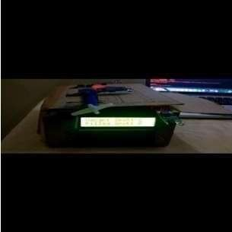

##### Fig :8.1 Shows both parking slot empty on the model

**CASE TWO**

This following case focuses on showing a slot number when the user is near to the parking detect sensor. It shows a parking slot number where the user should park his vehicle and upon parking it shows the start time of his parking.

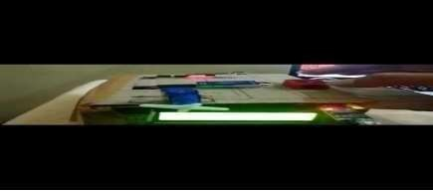

##### Fig 8.2 Case of one parking slot filled on the model CASE THREE

In this case we would display a message stating that there are no more empty slots

present in the parking zone .This message pop out when all the parking slots are filled and when a new vehicle turns up to the parking detect sensor requesting for an slot. Further the servo motor does not open the gates which makes it more sensible that there are no more parking slots available and the maintenance people should not upload any sign board indicating parking slots full . Saving human work in a efficient manner.

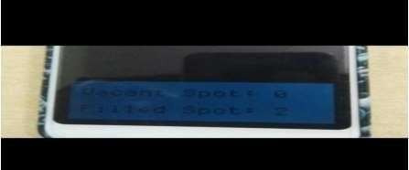

##### Fig 8.3 Updating the count of vacant and filledspotand displaying it .

**CASE FOUR**

This following case shows about unparking details where an user when unparks his vehicle from the parking slot he would be displayed.. Onsuccessfully unparking his vehicle the same would be updated in the count of 20*4display

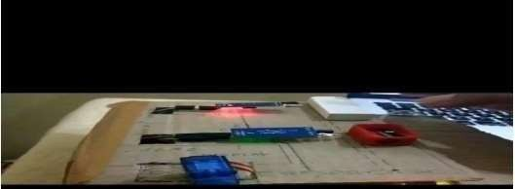

##### Fig 8.4 User unparking his vehicle from the slot

**CASE FI VE**

It’s is to test the compatibility of the wireless charging system with various electric vehicles to ensure that it can charge the batteries of the EVs at the appropriate power levels. This can be done by testing the system with different EV models and verifying that it works properly.

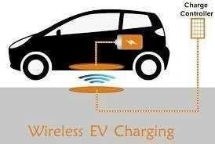

**Fig : 8.5 wireless charging in EV vechile**

# CHAPTER 9

**RESULTS AND DISCUSSION**

### INTIAL SETUP

The below diagram shows the initial case of the system when we turn on our project

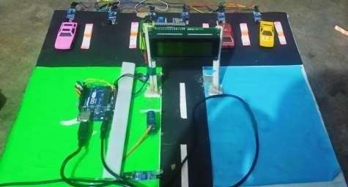,which indicates the number of vacant and filled spots on a 20*4display LCD.

### Fig 9.1 Showing the intial setup of the project

* 1. **PARKING AVEHICLE**

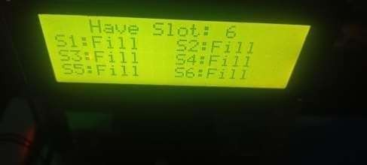The below diagram shows the status of the parking zone when a single vehicle is parked in the parking zone. Once when the user enters the parking detect sensor he would receive a parking slot number on uddated on 20*4 display .Upon parking the vehicle in the respective slot and IR sensor successfully detecting the vehicle.

### Fig :9.2 When one parking spot is filled

##### UNPARKING A VEHICLE

When a vehicle is unparked in a smart car parking system, the system may display information on an LCD display to confirm the successful completion of the unparking process. The specific information that is displayed may vary depending on the design of the system

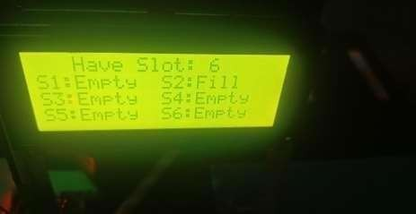

### Fig *9.3* When parking spot is not filled

**CONCLUSION**

The concept of Smart Cities has always been a dream for humanity. Since the past couple of years ago large advancements have been made in making smart cities reality. The growth of Internet of Things and Cloud technologies have given rise to new possibilities in terms of smart cities. Smart parking facilities and traffic management systems have always been at the core of constructing smart cities. In this project, we address the issue of parking and present an IoT based Cloud integrated smart parking system. The system that we propose provides real time information regarding availability of parking slots in a parking area. Users from remote locations could book a parking slot for them by the use of our mobile application**.**The efforts made in this project are intended to improve the parking facilities of a city and thereby aiming to enhance the quality of life of its people.

.

# REFERENCES

* + 1. Ahad, Zishan Raza Khan, Syed Aqeel Ahmad,“Intelligent Parking System” Scientific Research Publishing, Vol.4,No.2, pp. 160-167, May 2016.
    2. Dr Y Raghavender Rao,” Automatic Smart Parking System using Internet of Things (IOT)” International Journal of Engineering Technology Science and Research,Vol.4,No.5,pp.225-258,May2017
    3. Suprit Atul Gandhi, Hasan Mohammad Shahid,” Smart Parking System”
    4. Asian Journal of Convergence in Technology, Vol.4,No.1,May 2017Benson, J.P.,

T. O'Donovan, P. O'Sullivan, U. Roedig and C. Sreenan et al.,”Car park management using wireless sensor networks”, Proceedings of the 31st Conference on Local Computer Networks, Tampa, FL., USA., pp: 588-595 November 2006.

5 . Geng Y. and Cassandras C. G, “A new smart parking system based on optimal resource allocation and reservations,” in Proc. IEEE Conf. Intell. Transp. Syst. pp. 979– 984, July 2011.

6.M. M. Rashid, A. Musa, M. Ataur Rahman, and N. Farahana, A. Farhana, “Automatic Parking Management System and Parking Fee Collection Based on Number Plate Recognition.”, International Journal of Machine Learning and Computing, Vol. 2, No. 2, April 2012,Published 2014.

7.Arduino.cc. (2018). Arduino - ArduinoMega2560. , retrieved date: 21Oct.2018, online available [at:https://www.arduino.cc/en/Guide/ArduinoMega2560](http://www.arduino.cc/en/Guide/ArduinoMega2560)